Chapter 6 Physical Database Design and Performance

Chapter Overview

This chapter presents the basic steps that are required to develop an effective physical database design. Physical database design is very important since it immediately impacts those factors that are important to the end user: data integrity and security, response times, user friendliness, and so on. First, we present a simple approach to estimating the volume of data in a database, as well as the probable data usage patterns. Next, we discuss issues associated with defining fields, including data type determination, coding and compression techniques, controlling data integrity, and handling missing data. We then discuss designing physical records and include an expanded section on denormalization. Vertical and horizontal partitioning are covered next. We describe the basic file organizations and the trade-offs that are typically involved in selecting a file organization. We examine the use of indexes and have added bitmap indexes to this section. File access performance is discussed, including a new discussion of RAID technology. The chapter concludes with a comparison of available database architectures. The chapter continues to emphasize the physical design process and the goals of that process.

Chapter Objectives

Specific student learning objectives are included at the beginning of the chapter. From an instructor's point of view, the objectives of this chapter are to:
- Present physical database design as a critical element in achieving overall database objectives, rather than as an afterthought.
- Ensure that students understand the factors that must be considered in distributing data effectively and how a simple model can be used to obtain at least a first-cut distribution.
- Provide students with a sound understanding of the use of indexes and the trade-offs that must be considered in their use.
- Ensure students understand that denormalization must be used with great care and for specific reasons.

Key Terms

Bitmap Index | Hashed file organization | Physical record
Blocking factor | Hashing algorithm | Pointer
Data type | Horizontal partitioning | Redundant Array of Inexpensive Disks (RAID)
Denormalization | Index | Secondary key
Extent | Indexed file organization | Sequential file organization
Field | Join index | Stripe
File organization | Page | Tablespace
Hash index table | Physical file | Vertical partioning

Classroom Ideas
- Point out to your students that physical database design is the last step in the database design process. Suggest to your students that this step is where the "rubber meets the road," since regardless of how well previous steps may have been completed, users will not be happy with a sloppy physical design.
- Discuss data volume and usage analysis, using Figure 6-1.
- The Y2K problem can be used to highlight the process of selecting data types. The DATE data type is particularly interesting, both because of this problem, and because of its capability to calculate using date arithmetic in most RDBMSs.
- Using examples of each type of constraint can bring the importance of data integrity home. For instance, you can encourage the students to think through on their own or in small groups, situations where default values will improve data integrity, and situations where using them may decrease data integrity. Range controls, null value controls, and referential integrity can also be addressed this way.
- Discuss denormalization and the conditions under which this approach may be considered, referring to the discussion in the text. Be sure to describe the trade-offs in denormalization.
- Start a discussion of indexes by having the students give common examples (index at the end of their database text, Yellow Pages, card catalog, etc.). Then describe and illustrate the use of each type of index using Figure 6-7.
- Review the basic types of file organizations. Ask your students to give examples other than those described in the text for each organization.
- Encourage a discussion of the comparative desirability of the various levels of RAID. Students will probably be surprised to figure out that the answer to this question will not be in sequential order, and they should understand that the ordering would be affected by the performance required by the systems.
- Similarly, a comparison of the database architectures is a good opportunity to emphasize that hierarchical and network models are still in use, particularly for transaction processing systems, and that object-oriented databases are becoming much more common.
- Query optimization is a fascinating subject that is only touched on lightly in the book. Further examples, perhaps taken from the work of Joe Celko (Joe Celko's SQL Puzzles and Answers, and so forth), will be interesting to the students if time permits.

Review Questions
- Define each of the following terms:
- File organization A technique for physically arranging the records of a file on secondary storage devices.
- Sequential file organization Records in the file are stored in sequence according to a primary key value.
- Indexed file organization Records are either stored sequentially or non-sequentially, and an index is created that allows software to locate individual records.
- Hashing file organization The address for each record is determined using a hashing algorithm.
- Denormalization The process of transforming normalized relations into unnormalized physical record specifications.
- Composite key A key made up of more than one column.
- Secondary key One or a combination of fields for which more than one record may have the same combination of values.
- Data type Each unit of a detailed coding scheme recognized by system software, such as a DBMS, for representing organizational data.
- Bitmap index A table of bits in which each row represents the distinct values of a key and each column is a bit, which when on indicates that the record for that bit column position has the associated field value.
- Redundant Arrays of Inexpensive Disks (RAID) A set, or array, of physical disk drives that appear to the database user (and programs) as if they form one large, logical storage unit.
- Join index An index on columns from two or more tables that come from the same domain of values.
- Stripe The set of pages on all disks in a RAID that are the same relative distance from the beginning of the disk drive.
- Explain plan A command available in most database management systems which displays how the query optimizer will access indexes, use parallel servers and join tables to prepare query results.

2. Match the following terms to the appropriate definitions:
d bitmap index
f hashing algorithm
a page
g physical record
e pointer
b blocking factor
c physical file

- Contrast the following terms:
- Horizontal partitioning; vertical partitioning Horizontal partitioning is very similar to creating a supertype/subtype relationship because different types of the entity (where the subtype discriminator is the field used for segregating rows) are involved in different relationships, hence different processing. Neither horizontal nor vertical partitioning prohibits the ability to treat the original relation as a whole.
- Physical file; tablespace A physical file is a named portion of secondary memory (magnetic tape, hard disk) allocated for the purpose of storing records; a tablespace is a named set of disk storage elements in which physical files for database tables may be stored.
- Physical record; physical file A physical file is a named portion of secondary memory (a magnetic tape or hard disk) allocated for the purpose of storing physical records. Physical records of several types can be clustered together into one physical file in order to place records frequently used together close to one another in secondary memory.
- Page; physical record Often a page will store multiple physical records. Depending on the computer system, a lengthy physical record may or may not be allowed to span two pages.
- Secondary key; primary key A secondary key is one or a combination of fields for which more than one record may have the same combination of values; the primary key is one or a combination of fields for which every record has a unique value. Hence, the primary key is a unique identifier for a row.

- Three major inputs to physical design:
- Logical database structures developed during logical design
- User processing requirements identified during requirements definition
- Characteristics for the DBMS and other components of the computer operating environment

- Key decisions in physical database design:
- Choosing the storage format (called data type) for each attribute from the logical data model: the format is chosen to minimize storage space and to maximize data integrity.
- Grouping attributes from the logical data model into physical records: you will discover that although the columns of a relational table are a natural definition for the contents of a physical record, this is not always the most desirable grouping of attributes.
- Arranging similarly structured records in secondary memory (primarily hard disks) so that individual and groups of records can be stored, retrieved, and updated rapidly (called file organizations): consideration must also be given to protecting data and recovering data after errors are found.
- Selecting structures for storing and connecting files to make retrieving related data more efficient (called indexes and database architectures).
- Preparing strategies for handling queries against the database that will optimize performance and take advantage of the file organizations and indexes that you have specified: efficient database structures will be of benefit only if queries and the database management systems that handle those queries are tuned to intelligently use those structures.

- Composite usage maps:
Figure 6-1 illustrates a composite usage map, which shows both data volume and access frequencies for the illustrative Pine Valley Furniture inventory system. The volume and frequency statistics are generated during the systems analysis phase of the systems development process when systems analysts are studying current and proposed data processing and business activities. The data volume statistics represent the size of the business, and should be calculated assuming business growth over a several year period. The access frequencies are estimated from the timing of events, transaction volumes, and reporting and querying activities. Since many databases support ad hoc accesses, and such accesses may change significantly over time, the access frequencies tend to be less certain than the volume statistics. Fortunately, precise numbers are not necessary. What is crucial is the relative size of the numbers, which will suggest where the greatest attention needs to be given in order to achieve the best possible performance. It might also be helpful to know if an access results in data creation, retrieval, update, or deletion. Such a refined description of access frequencies can be handled by additional notation on a diagram such as in Figure 6-1 or by text and tables kept in other documentation.

- Developing field specifications:
- Define the data type used to represent values of the field.
- Establish data integrity controls for the field, including default values, ranges, null value controls, and referential integrity.
- Determine how missing values for the field will be handled.
- Other field specifications, such as display format, must be made as part of the total specification of the information system; those specifications are typically handled by programs rather than by the DBMS.

- Selecting a field data type:
These four objectives will have varying relative importance for different applications:
- Minimize storage space
- Represent all possible values
- Improve data integrity
- Support all data manipulations

- Coding or compressing field values:
Where attributes have a sparse set of values or a volume so large that considerable storage space will be consumed, possibilities for coding or compressing field values should be considered. Large data fields mean that data are further apart, which yields slower data processing. Where the set of valid values is small, translation into a code that requires less space is a possibility. Data compression techniques also use coding to reduce the storage space required for commonly recurring patterns of data.

- Controlling field integrity:
- Specify default values.
- Specify a range or list of permissible values.
- Set null value permissions.
- Establish referential integrity.

- Three ways to handle missing field values:
- Substitute an estimate of the missing value: for example, for a missing sales value when computing monthly product sales, use a formula involving the mean of the existing monthly sales values for that product indexed by total sales for that month across all products. Such estimates must be marked so users know that these are not actual values.
- Track missing data so that special reports and other system elements cause people to quickly resolve unknown values. Setting up a trigger in the database can accomplish this. A trigger is a routine that will automatically execute when some event occurs or time period passes. One trigger could log the missing entry to a file when a null or other missing value is stored, and another trigger could run periodically to create a report of the contents of this log file.
- Perform sensitivity testing so that missing data are ignored unless knowing a value might significantly change results. For example, if total monthly sales for a particular salesperson were almost over a threshold that would make a difference in that person’s compensation, then attention would be drawn to the missing value. Otherwise, it would be ignored. This is the most complex of the methods mentioned; it requires the most sophisticated programming, which must be written in application programs since DBMSs do not have the sophistication to handle this method.

- Effect of normalizing relations on physical record storage:
One goal of physical record design is efficient use of storage space. In most cases, the second goal of physical record design—efficient data processing—dominates the design process. Efficient processing of data, just like efficient accessing of books in a library, depends on how close together related data (or books) are. Often, all the attributes that appear within a relation are not used together, and data from different relations are needed together to answer a query or produce a report. Thus, although normalized relations solve data maintenance anomalies, normalized relations, if implemented one for one as physical records, may not yield efficient data processing.

- Situations that suggest the possibility of denormalization:
- Two entities with a one-to-one relationship: Even if one of the entities is an optional participant, if the matching entity exists most of the time, then it may be wise to combine these two relations into one record definition (especially if the access frequency between these two entity types is high). Figure 6-3 shows student data with optional data from a standard scholarship application a student may complete. In this case, one record could be formed with four fields from the STUDENT and SCHOLARSHIP APPLICATION normalized relations. (Note: In this case, fields from the optional entity must have null values allowed.)
- A many-to-many relationship (associative entity) with nonkey attributes: Rather than joining three files to extract data from the two basic entities in the relationship, it may be advisable to combine attributes from one of the entities into the record representing the many-to-many relationship, thus avoiding one join in many data access modules. Again, this would be most advantageous if this joining occurs frequently. Figure 6-4 shows price quotes for different items from different vendors. In this case, fields from ITEM and PRICE QUOTE relations might be combined into one record to avoid having to join all three files together. (Note: This may create considerable duplication of data—in the example, the ITEM fields, such as Description, would repeat for each price quote—and excessive updating if duplicated data changes.)
- Reference data: Reference data exists in an entity on the one-side of a one-to-many relationship, and this entity participates in no other database relationships. You should seriously consider merging the two entities in this situation into one record definition when there are few instances of the entity on the many-side for each entity instance on the one-side. See Figure 6-5 in which several ITEMs have the same STORAGE INSTRUCTIONs, and STORAGE INSTRUCTIONs only relate to ITEMs. In this case, the storage instruction data could be stored in the ITEM record, creating, of course, redundancy and potential for extra data maintenance.

- Advantages and disadvantages of horizontal and vertical partitioning:
Advantages of partitioning:
- Efficiency: Data used together are stored close to one another and separate from data not used together.
- Local Optimization: Each partition of data can be stored to optimize performance for its own use.
- Security: Data not relevant to one group of users can be segregated from data they are allowed to use.
- Recovery and uptime: Smaller files will take time to recover, and other files are still accessible if one file is damaged, so the effects of damage are isolated.
- Load balancing: Files can be allocated to different storage areas (disks or other media), which minimize contention for access to the same storage area or even allows for parallel access to the different areas.
Disadvantages of partitioning:
- Inconsistent access speed: Different partitions may yield different access speeds, thus confusing users. Also, when data must be combined across partitions, users may have to deal with significantly slower response times.
- Complexity: Partitioning is usually not transparent to programmers, who will have to write more complex programs due to violations of third normal form.
- Anomalies: Insertion, deletion, and update anomalies are possible, and special programming is required to avoid these problems.
- Extra space and update time: Data may be duplicated across the partitions, taking extra storage space, compared to storing all the data in normalized files. Updates, which affect data in multiple partitions, can take more time than if one file were used.

15. Seven criteria for selecting a file organization:
- Data retrieval speed
- Data input and maintenance transaction processing throughput rate
- Storage efficiency
- Failure or data loss protection level
- Frequency of data reorganization required
- Ability to accommodate growth
- Security protection provided

- The desirability of a bitmap index:
A bitmap is ideal for attributes that have few possible values, which is not true for conventional tree indexes. A bitmap also often requires less storage space (possibly as little as 25 percent) than a conventional tree index (Schumacher, 1997), but for an attribute with many distinct values, a bitmap index can exceed the storage space of a conventional tree index. One bitmap can be used for multiple keys in order to perform searches on elements that would satisfy more than one condition at a time.

- The benefits of a hash index table:
Using a hashing algorithm allows for rows stored independently of the address, so that whatever file organization makes sense can be used for storage. Also, because index tables are much smaller than a data table, the index can be more easily designed to reduce the likelihood of key collisions or overflows.

- The purpose of clustering data in a file:
Some database systems allow physical files to contain records with different structures, e.g., rows from different tables may be stored in the same disk area. This clustering reduces the time to access related records compared to the normal allocation of different files to different areas of a disk. Time is reduced since related records will be closer to each other than if the records are stored in separate files in separate areas of the disk.

- Seven rules of thumb for choosing indexes for relational databases.
- Indexes are more useful on larger tables.
- Specify a unique index for the primary key of each table.
- Indexes are more useful for columns that frequently appear in WHERE clauses of SQL commands, either to qualify the rows to select (e.g., WHERE FINISH = ‘Oak’, for which an index on Finish would speed retrieval ) or for linking (joining) tables (e.g., WHERE PRODUCT.PRODUCT_ID = ORDER_LINE.PRODUCT_ID, for which a secondary key index on Product_ID in the Order_Line table and a primary key index on Product_ID in the Product table would improve retrieval performance). In this second case, the index is on a foreign key in the Order_Line table that is used in joining tables.
- Use an index for attributes referenced in ORDER BY (sorting) and GROUP BY (categorizing) clauses. You do have to be careful, though, about these clauses. Be sure that the DBMS will, in fact, use indexes on attributes listed in these clauses (e.g., Oracle uses indexes on attributes in ORDER BY clauses but not GROUP BY clauses).
- Use an index when there is significant variety in the values of an attribute. Oracle suggests that an index is not useful when there are fewer than 30 different values for an attribute, and an index is clearly useful when there are 100 or more different values for an attribute. Similarly, an index will be helpful only if the results of a query that uses that index do not exceed roughly 20 percent of the total number of records in the file (Schumacher, 1997).
- Check your DBMS for the limit, if any, on the number of indexes allowable per table. Many systems permit no more than 16 indexes and may limit the size of an index key value (e.g., no more than 2000 bytes for each composite value). So, you may have to choose those secondary keys that will most likely lead to improved performance.
- Be careful about indexing attributes that have null values. For many DBMSs, rows with a null value will not be referenced in the index (so they cannot be found from an index search of ATTRIBUTE = NULL). Such a search will have to be done by scanning the file.

- Two views of multidimensional databases:
- Multidimensional table: Each cell contains one or more simple attributes, and the dimensions are ways to categorize the raw data. These categories, or dimensions, are the factors on which users want to summarize or segment the data, such as time periods, geography, lines of business, or people. A cell contains data relevant to the intersection of all of its dimension values. For example, a cell might hold the number of units sold attribute for a given time period, location, line of business, and salesperson.
- Star-schema: At the center is a fact table, equivalent to the cell in the multidimensional view. This table contains all the raw attributes and a composite key made up of the primary keys of all the surrounding dimension tables. The surrounding dimension tables define each of the ways to categorize data, such as all the description data about each salesperson.

21. How can the use of the EXPLAIN command help in writing a more efficient query:
EXPLAIN plan will show exactly how a query will be submitted to the DBMS for processing. We can see indexes used, servers used, and how tables will be joined. Different execution plans for the query written in several different ways will help identify the least-cost execution for a desired query. The query with the best performance can then be chosen.

22. Four options for optimizing query performance:
- The most common approach is to replicate the query so that each copy works against a portion of the database, usually a horizontal partition (sets of rows). The partitions need to be defined in advance by the database designer. The same query is run against each portion in parallel on separate processors, and the intermediate results from each processor are combined to create the final query result as if the query were run against the whole database.
- A second option for using parallel scanning of a table occurs when the query is written. When the DBMS parses a query, it decides, based on statistics it keeps about the database structure, the number of distinct values for fields; and the query, what the best strategy is—called a query plan—for accessing each index and table. The DBMS includes rules that consider these statistics, and the DMBS uses these rules to pick the best query plan. The module of the DBMS that does these calculations is called the cost-based optimizer. The query plan calculated by the cost-based optimizer says what table or index to use first and how to use it, then what table or index to use next, and so on. Oracle includes an ANALYZE command which collects these statistics and stores them for use by the DBMS. It is possible in some DBMS to give the DBMS a hint or suggestion within the query to force the DBMS to process the query in a certain way.
- Avoid the use of subqueries. SQL allows nesting of queries, or writing one query inside another. The types of queries are less efficient than queries that retrieve the same data set with the subquery.
- Break complex queries into multiple, simple parts. Because a DBMS may only have one index per query, it is often good to break a complex query down into multiple, simpler parts which each use an index. Then combine the results of the smaller queries together.

Answers to Problems and Exercises

- STUDENT_ID in STUDENT because it is a primary key and the index would enforce uniqueness of the key; also, STUDENT_ID in STUDENT and in REGISTRATION is used in a WHERE clause for joining the STUDENT and REGISTRATION tables, so it likely makes sense to create an index on STUDENT_ID in REGISTRATION as well.

GPA in STUDENT because it is a nonkey cluster attribute used to qualify record retrieval

STUDENT_NAME in STUDENT because it is a nonkey attribute used to sort records

STUDENT_ID, COURSE_ID in REGISTRATION because it is a concatenated primary key and the index would enforce uniqueness of the key

- CREATE UNIQUE INDEX STUPKINDX ON STUDENT (STUDENT_ID);
CREATE INDEX STUDREGINDX ON REGISTRATION (STUDENT_ID);
CREATE INDEX CLUST_INDX
ON STUDENT (GPA)
CLUSTER;
CREATE INDEX NAMEINDX ON STUDENT (STUDENT_NAME);
CREATE UNIQUE INDEX REGSPKINDX ON REGISTRATION (STUDENT_ID, COURSE_ID);

- Assuming that Vendor_ID and Price hold data that fits the two byte field size:
Vendor_ID SMALLINT
Address VARCHAR(40)
Contact_Name VARCHAR(25)
Item_ID INTEGER
Description VARCHAR(35)
Price SMALLINT

- The answer to this question will vary for different universities, but common situations are used here. Since the majority of students are accepted in the first year after high school graduation and university attendance is increasing, the average age of students in the first year of college would be a good choice for a default value. Often students are accepted at the different schools within the university after the second year. Therefore we need to add two years to the first answer if we design the system for a business school, for example. Degree seeking students are generally younger than non-degree seeking students, and the default value for this field might be a higher number for non-degree seeking students. Graduate students have already completed a degree, which usually takes at least four years, so a graduate university would also use a higher default value.

- Since every student who hasn't explicitly declared a major of his or her choice would be assigned this value, it should be considered a default value. The null value is an empty value.

EMPLOYEE_SCHEDULE
(Department_ID, Employee_ID, Where_Work, Employee_Name, Employee_Address, Date)

A many-to-many relationship (associative entity) with nonkey attributes: Rather than joining three files to extract data from the two basic entities in the relationship, it may be advisable to combine attributes from one of the entities into the record representing the relation in the many-to-many relationship, thus avoiding one join in many data access modules. This approach is advantageous as this joining will occur frequently.

DEPARTMENT
(Department_ID, Manager_ID, Sales_Goal, Store_ID, Region, Manager_ID, Square_Feet)

This reference data denormalization option wouldn't be recommended since the table STORE is further related to a table MANAGER, and there are probably more than just a few departments in each STORE.

- Sixteen records will fit on one page, using 3840 of the 4000 bytes available per page. This means that 4000 - 3840 =160 bytes will be lost from each page since records may not span pages. A total of 1000/16 or 62.5 sets of 16 bytes will be needed—or 63 pages. Sixty-three pages will take up 252,0000 bytes of storage.

Disadvantages of partitioning:
- Inconsistent access speed: Different partitions may yield different access speeds, which may confuse users.
- Complexity: Partitioning is usually not transparent to programmers, who will have to write more complex programs due to the violations of third normal form.
- Anomalies: The violations of third normal form will lead to anomalies.
- Extra space and update time. Duplication of data across the partitions will use more storage space than data stored in normalized files. Updates may well affect data in multiple partitions.

Conditions that influence the use of partitioning:
- Criticalness of fast and consistent record access times to users
- Sophistication of in-house programming talent
- Storage space availability

- A sequential file organization arranges the records in physical sequence based on one sorting criterion, so scanning the file in that sequence is possible and efficient. For sequential media, really the only practical scanning sequence is the sequence in which the records are stored. If the sequential file is, however, on a random access device, then although the storage sequence is still the fastest scanning sequence, other sequential scans are possible by using pointers to link the records in order for the sequences in addition to the physical sequence.

- Records can be accessed sequentially in two directions: from start to end and vice versa. As a corollary, it is easy to find the next or prior record in sequence if you now the address of a particular record.
- What is described is a simple, bi-directional pointer --which will allow traversal through the records in two directions forward and backward—but does not allow for different sequences. However, by adding a pair of bi-directional pointers for each sequence, multiple sequences can be maintained without repeating the data.

- A row selection qualification clause will be used:

WHERE (Major = "MIS" or Major = "Computer Science") And Age > 25 And Marital_Status = "single") Or (Major = "Computer Engineering" And Marital_Status = "single" And Home_Zipcode = 45462). Indexes on these fields can be used to considerable advantage in this situation. Assume that each index qualification (e.g., Major = “MIS”) produces a list of record numbers for the records satisfying that qualification. Lists can be merged to process OR operators, and lists can be intersected to process AND operators. Indexes may be scanned in main memory, and the list operations also done without accessing secondary memory, thus composing the list of qualified records very quickly. Only then does secondary memory need to be accessed for only those records that satisfy the whole query.

11.

Student Table Row Numbers
Marital_  Status | 101 | 102 | 103 | 104 | 105 | 106 | 107 | 108 | 109 | 110 | 111
Single | 0 | 0 | 0 | 1 | 1 | 1 | 1 | 0 | 1 | 0 | 1
Married | 1 | 0 | 1 | 0 | 0 | 0 | 0 | 1 | 0 | 0 | 0
Other | 0 | 1 | 0 | 0 | 0 | 0 | 0 | 0 | 0 | 1 | 0

A bitmap is ideal for attributes that have a few possible values. It requires less storage space (possibly as little as 25 percent) than a conventional tree index.

12. Consider Figure 6-7c.
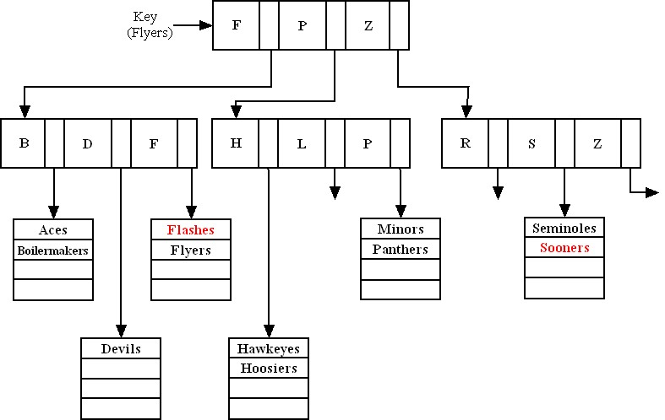

When one of the leaves is full and a new record needs to be added to that leaf, the leaf node may be turned into an intermediate parent node. This node would then serve as an index to those records, and an additional leaf node (containing the actual records) will be attached to that intermediate node. The parent node will contain pointers to the records in the leaf node.

13.

There are two different multidimentional models in Figure 6-12. Both view facts (e.g., sales) qualified by different dimensions (e.g., product, region, and month). The cube is really a way to display the data, and can be represented via the star-schema view in the database. A skeleton of the star schema view for the cube would be the following:

PRODUCT (Product_ID, other data describing products)
REGION (Region_ID, other data describing regions)
DATE (Date_ID, other data describing dates [months])
SALES (Product_ID, Region_ID, Date_ID, dollar sales, unit sales, other such facts)

- A cluster is defined by the tables and the column or columns by which the tables are usually joined. The column by which they are joined (foreign key) would need to have the same value in the two tables for the adjacent records. If the tables are populated with data before clustering occurs, this is much harder to achieve. Hence, in Oracle, tables are assigned to a cluster at the time of their creation.

- In general, the answer depends on the number of processors available. For the general structure mentioned in the problem, each set of conditions within parentheses (called a conjunction) could be given to a separate processor, then the results from each processor would be intersected to obtain the final result. If more processors are available, then each condition within a conjunction could be assigned to its own processor.

As an illustration of what might typically happen, consider the qualification clause from Problem and Exercise 10:

SELECT STUDENT_ID, STUDENT_NAME
FROM STUDENT
WHERE (Major = "MIS" or Major = "Computer Science") And Age > 25 And
Marital_Status = "single" Or (Major = "Computer Engineering" And Marital_Status = "single" And Home_Zipcode = 45462);

There are two general approaches for parallel processing of a query:

- To ensure that subsequent scans of this table are performed in parallel using at least three processors, you would first alter the structure of the table with the SQL command:

ALTER TABLE STUDENT PARALLEL 3,

and then run the query itself.

- The second option would be to give the DBMS a hint within the query. This will force it to process the query in a certain way. In Oracle:

SELECT /*+ FULL(STUDENT) PARALLEL(STUDENT,3) */ COUNT(*)
FROM STUDENT
WHERE (Major = "MIS" or Major = "Computer Science") And Age > 25
And Marital_Status = "single" Or (Major = "Computer Engineering" And Marital_Status = "single" And Home_Zipcode = 45462);

would enforce a full scan on the table STUDENT, and its processing in parallel, by three CPUs. (Note: In Oracle, parallel processing is possible only when a table is scanned, not when it is accessed through an index.)

16.
CustRowID | OrderRowID | Cust#
10001 | 30004 | C2027
10002 | 30002 | C1062
10003 | 30003 | C1062
10004 | 30001 | C3861
… | … | …

17.
Notes to instructor: This problem & solution references an older version of Figure 6-1, where the QUOTATION table below is the same as the SUPPLIES table in 9e version of the textbook. Also note that the (40) and 40 numbers around QUOTATION are due to assumptions regarding raw number analysis of queries against the database. An alternative solution to the one below would allow for 90 accesses of QUOTATION/SUPPLIES due to the increase in the direct accesses to PURCHASED_PART (now 150+75=225; was 140+60=200 with 80 accesses).
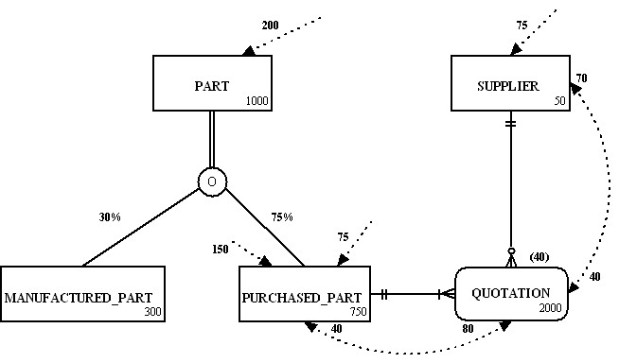
18.
a.
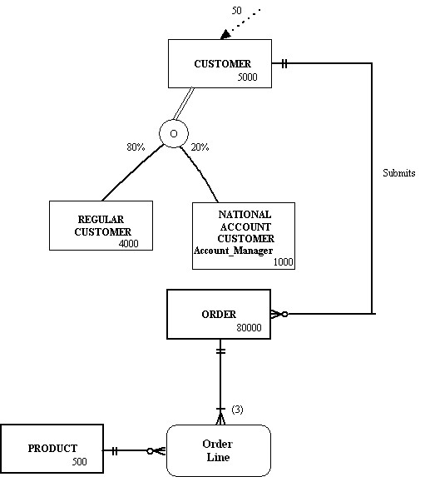

It might also be useful to ask your students what type of additional usage data might need to be gathered to make a complete analysis.

b. Since only employees are using the system, one possibility might be to eliminate the regular customer and national account customer subtypes and only have one customer type. We might also assume that only national account customers would be serviced by employees. Depending on how much National Account Customer data there is, this and the Order Line entities might be merged.

19.
a. An index on the State field of the customer table would help with grouping and sorting. An index on Order_Date in the order table would help with qualifying to the desired period. If rows are sorted by description within state, it would seem that a index on Product_Description in the product table might be helpful, but such an index would likely not be used by most DBMSs because the number of rows to sort within each category is so few.

b. An index on Product_Finish in the Product table would help to compute the totals by product finish.

- An index on Order_Date would help to quickly find the desired orders, and an index on Order_ID in the order line table would speed joining.

- An index on Product_Line_ID in product would speed grouping, and an index on Product_ID in the order line table would speed joining.

Suggestions for Field Exercises

- A good starting point for the purposes of this assignment would be to identify any DBMSs that support complex data types like graphics, video, and sound. Object-oriented databases will stand out for their abilities in this regard. This is the newest DBMS technology and larger organizations are gaining experience with it by selectively using it when complex data or event-driven programming is appropriate for the application.

- Students who investigate this question may become interested in understanding the difference between symmetric multiprocessing (SMP) and massively parallel processing (MPP), topics that are covered in more depth in Chapter 9. In a typical SMP architecture, the machine has up to a few dozen processors, and each processor shares all hardware resources, including memory, disks, and the system bus. Because each processor can see all of the available memory, communicating between processors is straightforward: one processor can easily view the results generated by another processor simply by looking at the appropriate section of memory. MPP machines support multiple nodes that each have their own private memory and that communicate via passing messages over an interconnect. SMP systems seem to be best suited for either mission-critical or OLTP applications, where the application's growth rate is slow and steady at less than 20 percent annually and the amount of raw data is in the range of 10 to 100GB. MPP systems are best suited for either complex analytical or very large decision-support applications.

Students may also discover that several options exist for breaking apart a query into modules that can be processed in parallel. All options are not available with every DBMS, and each DBMS often has unique options due to its underlying design.

- Student answers will vary based on the organization, its standards, and the people they actually contact within the organization. Answers should evidence a belief (fully normalized or denormalized databases) as well as a rationale for the belief.

- In choosing a file organization for a particular file in a database, students should find that database designers consider many of these seven factors:
- Fast data retrieval
- High throughput for processing data input and maintenance transactions
- Efficient use of storage space
- Protection from failures or data loss
- Minimizing need for reorganization
- Accommodating growth
- Security from unauthorized use

Secondary key indexes are important for supporting many reporting requirements and for providing rapid ad hoc data retrieval. Indexed sequential in comparison to indexed nonsequential allows more efficient use of space and faster sequential data processing without much, if any, sacrifice in random data record accessing speed. A bitmap is ideal for attributes that have even a few possible values, which is not true for conventional tree indexes. Indexes may be deleted because of storage space constraints or to reduce maintenance overhead.

5. Redundant Arrays of Inexpensive Disks (RAID) is hardware and software technology that helps the database designer accomplish parallel database processing. The result of parallel processing of data is that several input/output operations, when done in parallel, take as long as only one such operation. RAID-1 is best for fault-tolerant, database maintenance applications (those requiring a high percentage of up time) or when only two disk drives are affordable. RAID-5 is best for read-intensive applications against very large data sets and when at least three (and more typically five or more) disk drives are affordable. DBAs favor RAID-1 because of the fast recovery time when a problem develops with a disk, but they may not always be able to afford the required storage space.

Project Case

Case Questions
1.
a. Data volume estimates (data volume and frequency-of-use statistics, representing them by adding notation to the EER diagram)
b. Definitions of each attribute
c. Descriptions of where and when data are used: entered, retrieved, deleted, and updated (including frequencies)
d. Expectations or requirements for response time and data security, backup, recovery, retention, and integrity
e. Descriptions of the technologies (database management systems) used for implementing the database. The efficient use of secondary storage is influenced both by the size of the physical record and the structure of secondary storage. Hence, we need to know the page size, whether a physical record is allowed to span two pages, and the blocking factor, etc.
2. Some types of data that are collected include medical records (e.g., scanned from manual systems), lab results, test results, hand written doctor notes, doctor dictations, etc. Some data, such as audio clips, MRI images, or x-rays could not be captured using standard data types. Some items can be converted to alphanumeric datatypes (e.g., dictation can be transcribed). One option would be to use other datatypes such as binary large objects (BLOBS). Increasingly, jpeg, mpeg, and other rich media objects need to be accommodated.
3. Data partitioning would be beneficial if the database is going to be distributed among different machines. Horizontal partitioning distributes all the rows of a table in separate files, based upon common column values. When data are needed to be viewed together the SQL union operator may be used to display all rows of data in one table. Vertical partitioning, or distributing the columns of a relation in separate files by repeating the primary key for each file, would be another possibility. By joining the tables together, all data may be viewed together. Where the natural divisions are to partition the data are not clear. Some labs may run rather independently, so some data only for use in one or a few labs could be stored in a separate partition. However, the push for integrated, electronic medical records encourages one integrated database of medical data. Some hospitals use different applications for medical records and for practice management (the back office functions). Thus, these applications may be supported by separate partitions (possibly with some planned redundancy).
4. A bitmapped index could be used on fields such as Skill in the Volunteer and Technician relations, Specialty in the Physician relation and Job_Class in the Staff relation. Bitmapped indexes would work well in all of these cases because each column being indexed has a small number of possible values. One possible join index would be Care_Center_ID in the NURSE relation and the BED relation. This might be useful in a data warehousing application, particularly if you would like to report on what nurses could potentially work in what rooms and care for patients in what beds.
5.
a. The following secondary indexes are recommended:
Treatment_Date on the order_treatment table since this indicates the date of treatment

Treatment_Code on the order_treatment table since we will group by treatment_code

P_Person_ID on the order_treatment table since this will link to the physician table

Physician_Name on the physician table since we will also want to search by physician_name

b. The statements are:
create index tdate on order_treatment(treatment_date);
create index tcode on order_treatment(treatment_code);
create index rphys on order_treatment(p_person_id);
create index rphys_name on physician(physician_name);

6. RAID technology would be useful for the hospital, especially since it is critical to keep access to the data available 24 by seven. With RAID, we can be sure that there is some redundancy built in.

7.
a. MVCH could benefit from voluntary compliance since this would increase the quality of the data. While MVCH would have to provide more detailed reporting on financials, it still would stand to gain much in terms of quality which would be looked upon favorably by accrediting agencies such as JCAHCO. Also, SOX compliance might help MVCH justify some quality awards, which could be used for competitive advantage in promoting the hospital against alternative healthcare providers.

- Accuracy and completeness of MCVH is attained through including some range controls and other integrity controls during physical database design.

Elimination of duplicates and data inconsistencies will be achieved by using a data model in 3NF (or with planned denormalization) as well as including appropriate referential integrity.

MVCH data will be more understandable if some physical data naming conventions and standards are used.

Case Exercises

a. Yes, I would change all TEXT to VARCHAR since this would dynamically allocate memory space for the fields and will help to minimize storage space.

b. Yes, I would include lookup tables for Social_Worker, Pain_Level and reason for visit, for example.

c. Patient_No, Name, and Social_Worker in the patient table should have values. First_seen could be null, since the patient info may be entered before the patient is seen.

In the Visit table, new_symptoms could be null.

d. I would write a trigger to write to an exceptions table. This table would then be used to generate a report. I would not use a default value for social worker. For reason_for_visit, I might use routine as the default value. Alternatively, applications that populate these fields could force these data to be included, other wise a transaction (e.g., recording a visit) cannot be entered. It might be possible to reuse the most recent value for reason for a visit, assuming the most likely reason is a continuation of the most recent reason. However, in this case, or any case of entering a value for a missing field, it is best to indicate that the value stored is an estimate, and that the real value is unknown, until the value can be verified.

e.
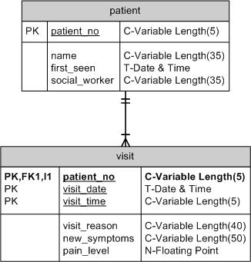

2.
a. Yes. I would create a UDT called test_results which contains the test_name, last date, and result. This would eliminate separate fields in the PATIENT table for each type test (MRI, FSS, etc.).

b. Yes, presenting symptoms and active meds in the visit table both could be coded with a list. Stage in the patient could also be coded with a list.

- Active_meds could take on a null value, since the patient does not always need to be on meds. The same is true for last_MRI_results and MRI_Results since some patients will not have an MRI. The same would be true for FSS, EDSS and neuro assessment.

d. I do not see any possibilities for denormalization here.

e. Yes, one possibility is stage, since there would be a limited number.

f. I could see using a join index across all tables since MRN is a common field.

3.
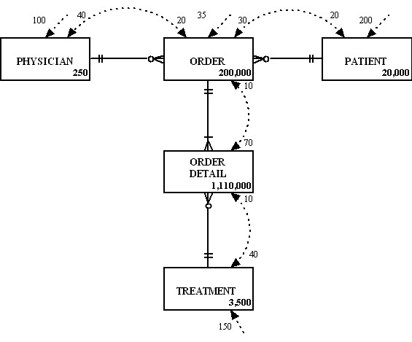

4. I would recommend clustering order and order_detail, using the order_id as the cluster key due to data volumes. SQL Server does support clustering through a cluster key, which physically rearranges the order of the records. The Oracle implementation actually stores the two or more tables next to each other on the disk.

5. VARCHAR is not available in Access. Also, the date datatype is a datetime datatype in Access.

6.
a. Here is a table-by-table review:

Table Name | Design Changes/Comments
Assignment_T | CareCenter_ID and Employee_ID should be of type text to all for IDs that start with 0.
Assignment_T | Hours_Worked could have a default value of 37.5 and should not allow negative values.
Bed_T | Bed_ID, CareCenter_ID and Room_ID should be text to allow for IDs that start with 0.
Care_Center_T | CareCenter_ID and Employee_ID should be of type text to all for IDs that start with 0.
Care_Center_T | CareCenter_Type could use a lookup table.
Care_Center_T | In_Charge should have a range of either 0 or 1.
Consumes_T | Item_ID and Patient_ID should be of type text to all for IDs that start with 0.
Consumes_T | Time_Received could be stored inside of date_received since this is a date/time field.
Consumes_T | Quantity should be required and should not allow anything less than 0.
Employee_T | Employee_ID and Person_ID should be of type text to all for IDs that start with 0.
Employee_T | Employee_Type could use a lookup table.
Item_T | Item_ID should be of type text to all for IDs that start with 0.
Item_T | Item_cost should be greater than 0.
Patient_T | Patient_ID, Person_ID, and Bed should be of type text to all for IDs that start with 0.
Patient_T | Contact_Time could be incorporated into Contact_Date since this is a date_time field.
Patient_T | Contact_Date should be today or before.
Patient_T | Admission_Type could use a lookup table
Performs_T | Patient_ID, Physician_ID, and Treatment_ID should be of type text to all for IDs that start with 0.
Performs_T | Treatment_time could be incorporated into Treatment_Date since this is a date_time field.
Person_T | Person_Number should be of type text to all for IDs that start with 0.
Person_T | Person_Birthdate should be today or earlier.

(6a solution continued on next page)

Table Name | Design Changes/Comments
Physician_T | Person_Number should be of type text to all for IDs that start with 0.
Physician_T | Speciality could use a lookup table.
Treatment_T | Treatment_ID should be of type text to all for IDs that start with 0.
Volunteer_T | Volunteer_ID and Person_IDshould be of type text to all for IDs that start with 0.
 | Skill could use a lookup table

b.
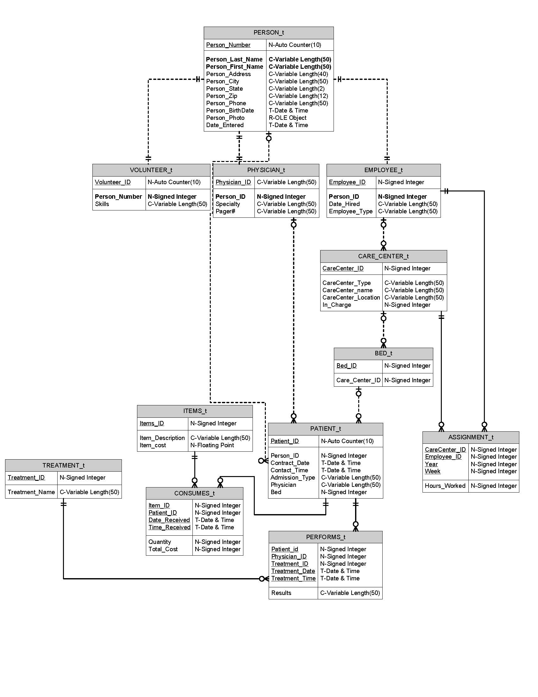

c. A couple of possibilities: Consumes_T with Item_T using Item_ID
Performs_T with Treatment_T using Treatment_ID
Project Assignments

P1. The data types for each field in the database are defined in P2 solution (the data dictionary). Following is a discussion of each of the raised issues:

P1.1 Opportunities for user-defined data types: User-defined data types are discussed in the context of evolving SQL standards in chapter 8 of the textbook. There do not appear to be any opportunities to use user-defined data types in this case exercise.

P1.2 Coding possibilities. The following fields are candidates for coding:

Table Name | Field Name | Coding Scheme
Vol_Language | Language | List most common (e.g., French, Spanish, etc.)
Vol_Skill | Skill | List out possible values
Vol_Interest | Interest | List out possible values
Vol_Availability | Day_of_Week | List
Vol_Availability | Portion_of_Day | List
Employee | Emp_Type | Staff, Technician, Nurse
Nurse | Nurse_Type | RN, LPN
Physician | Physician_Specialty | List those recognized by professional medical associations
Nurse | Nurse_Specialty | List those recognized by professional medical assoications
Work_Unit | Unit_Type | CC, DU
Technician_Skill | TS_Skill | List recognized professional skills
Staff | Job_Class | List recognized job classes for MVCH

P1.3 Null values. The following fields could have null values (selected examples), however it might be a good design idea to set up default values for a “not applicable” value for text-based data rather than leaving fields null:

Table Name | Field Name | Explanation
Assessment | Comments | There could be no comments at time of assessment.
Treatment_Order | Results | A treatment’s results might not be filled in yet
Item_Billing | End_Date | It might not be the end of an item’s usage for billing yet.
Person | Person_Work_Phone | A patient that is a child/minor may not have a work phone
Volunteer | Felony_Explanation | No felony to report.
 | V_Employer_Addr, Position, Start_Date, End_Date | Volunteer may not be working, or with current work may not have an end-date
Vol_Serv_History | Service_End_Date | May be currently volunteering, thus no end date yet
Resident | Date_Discharged | Not yet discharged
CC_Assignment | Assign_End | Assignment not yet completed

P1.4 Indexed fields: Primary key and Foreign Key fields should be indexed. Additional suggestions for secondary indexes are noted in the solution to P2.

P2. Please see the table-by-table solution for the data dictionary; the solution assumes usage of Oracle data types for fields, there may be slight differences for MS SQL Server, MySQL, or MS Access implementation specifics.

Table: Person
Data Item |  | Value
Name | Type | Length | Min | Max | Description | Index | PK | FK | References
Person_ID | Varchar | 5 |  |  | Person ID |  | Y
Person_Name | Varchar | 35 |  |  | Name
Person_Str_Address | Varchar | 20 |  |  | Address
Person_City | Varchar | 20 |  |  | City
Person_State | Varchar | 2 |  |  | State
Person_Zip | Varchar | 10 |  |  | ZipCode
Person_Home_Phone | Varchar | 14 |  |  | Phone Number
Person_Work_Phone | Varchar | 14 |  |  | Phone Number
Person_DOB | Date |  |  |  | Date of Birth
Person_Email | Varchar | 25 |  |  | E-mail address
Is_Physician | Char | 1 | “N” | “Y” | Subtype Discriminator
Is_Employee | Char | 1 | “N” | “Y” | Subtype Discriminator
Is_Volunteer | Char | 1 | “N” | “Y” | Subtype Discriminator
Is_Patient | Char | 1 | “N” | “Y” | Subtype Discriminator

Table: Physician
Data Item |  | Value
Name | Type | Length | Min | Max | Description | Index | PK | FK | References
Physician_ID | Varchar | 5 |  |  | Person ID |  | Y | Y | Person(Person_ID)
DEA_No | Varchar | 20 |  |  | DEA number
Pager_no | Varchar | 14 |  |  | Number for pager
Specialty | Varchar | 20 |  |  | Physician medical specialty

Table: Physician_DX
Data Item |  |  | Value
Name | Type | Length |  | Min | Max | Description | Index | PK | FK | References
PD_ID | Number | 5 |  |  |  | Unique ID for Physician & Diagnosis instance |  | Y
Diagnosis_Date | Date |  |  |  |  | Date of diagnosis
Diagnosis_Time | Timestamp |  |  |  |  | Time of diagnosis
Physician_ID | Varchar | 5 |  |  |  | Physician ID who made the diagnosis | Y secondary |  | Y | Physician(Physician_ID)
Patient_ID | Varchar | 5 |  |  |  | Patient receiving diagnosis | Y secondary |  | Y | Patient(Patient_ID)
Diagnosis_Code | Varchar | 5 |  |  |  | Diagnosis Code | Y secondary |  | Y | Diagnosis(Diagnosis_Code)

Table: Diagnosis
Data Item |  | Value
Name | Type | Length | Min | Max | Description | Index | PK | FK | References
Diagnosis_Code | Varchar | 5 |  |  | Hospital recognized codes for medical diagnoses |  | Y
Diagnosis_Name | Varchar | 60 |  |  | Name of diagnosis

Table: Employee
Data Item |  | Value
Name | Type | Length | Min | Max | Description | Index | PK | FK | References
Emp_ID | Varchar | 5 |  |  | Person ID |  | Y | Y | Person(Person_ID)
Date_Hired | Date |  |  |  | Hire date of employee
Emp_Type | Char | 1 | “N” | “T” | Subtype discriminator; values of N, S or T only

Table: Technician
Data Item |  | Value
Name | Type | Length | Min | Max | Description | Index | PK | FK | References
Technician_ID | Varchar | 5 |  |  | Person ID |  | Y | Y | Employee(Emp_ID)
Unit_Name | Varchar | 20 |  |  | FK to Work_Unit where technician assigned |  |  | Y | Work_Unit(Unit_Name)

Table: Technician_Skill
Data Item |  | Value
Name | Type | Length | Min | Max | Description | Index | PK | FK | References
TS_ID | Varchar | 5 |  |  | Unique ID for Technician skill instance |  | Y
Technician_ID | Varchar | 5 |  |  | FK to Technician |  |  | Y | Technician  (Technician_ID)
TS_Skill | Varchar | 20 |  |  | Specific recognized medical skill

Table: Staff
Data Item |  | Value
Name | Type | Length | Min | Max | Description | Index | PK | FK | References
Staff_ID | Varchar | 5 |  |  | Person ID |  | Y | Y | Employee(Emp_ID)
Job_Class | Varchar | 3 |  |  | Job classification code | Y bitmapped
Unit_Name | Varchar | 20 |  |  | FK to Work_Unit where staff assigned |  |  | Y | Work_Unit(Unit_Name)

Table: Work_Unit
Data Item |  | Value
Name | Type | Length | Min | Max | Description | Index | PK | FK | References
Unit_Name | Varchar | 20 |  |  | Name of Work_Unit in hospital |  | Y
Floor | Varchar | 3 |  |  | Floor where work_unit is located
Facility_ID | Varchar | 10 |  |  | FK to Facility |  |  | Y | Facility(Facility_ID)
Unit_Type | Char | 2 | “CC” | “DU” | Subtype discriminator; values of CC or DU only

Table: Volunteer
Data Item |  | Value
Name | Type | Length | Min | Max | Description | Index | PK | FK | References
Vol_ID | Varchar | 5 |  |  | Person ID |  | Y | Y | Person(Person_ID)
Had_Felony | Char | 1 | “N” | “Y” | Yes/no for felony question
Felony_Explanation | Varchar | 50 |  |  | Text explanation
VEC_Last_Name | Varchar | 20 |  |  | Last name of emergency contact
VEC_First_Name | Varchar | 20 |  |  | First name of emergency contact
VEC_Relationship | Varchar | 15 |  |  | Relationship of emergency contact to volunteer
VEC_Address | Varchar | 55 |  |  | Street, city, zip address of emergency contact
VEC_Phone | Varchar | 14 |  |  | Phone number of emergency contact
V_Employer | Varchar | 25 |  |  | Name of volunteer’s employer
V_Employer_Addr | Varchar | 55 |  |  | Address of volunteer’s employer
V_Employ_Position | Varchar | 20 |  |  | Volunteer’s employment position
V_Employ_Start_Date | Date |  |  |  | Starting date of volunteer employment
V_Employ_End_Date | Date |  |  |  | Ending date of volunteer employment
Had_MVCH_Serv | Char | 1 | “N” | “Y” | Yes/no answer to volunteer having served at MVCH
Had_Vol_Exp | Char | 1 | “N” | “Y” | Yes/no answer to volunteer having experience
Why_Volunteer | Char | 50 |  |  | Text explanation

Table: Vol_MVCH_Service
Data Item |  | Value
Name | Type | Length | Min | Max | Description | Index | PK | FK | References
VMS_ID | Varchar | 5 |  |  | Unique ID for Volunteer’s MVCH Service experience |  | Y
MVCH_Service_Info | Varchar | 25 |  |  | Service information
Vol_ID | Varchar | 5 |  |  | FK to Volunteer |  |  | Y | Volunteer(Vol_ID)

Table: Vol_Ref_Info
Data Item |  | Value
Name | Type | Length | Min | Max | Description | Index | PK | FK | References
VRI_ID | Varchar | 5 |  |  | Unique ID for Volunteer’s Reference Info instance |  | Y
VRI_Last_Name | Varchar | 20 |  |  | Last Name of Volunteer’s reference person
VRI_First_Name | Varchar | 20 |  |  | First Name of Volunteer’s reference person
VRI_Relationship | Varchar | 15 |  |  | Relationship of volunteer’s reference
VRI_Phone | Varchar | 14 |  |  | Phone number of volunteer’s reference
VRI_Address | Varchar | 20 |  |  | Street address of volunteer’s reference
VRI_City | Varchar | 20 |  |  | City of volunteer’s reference
VRI_State | Varchar | 2 |  |  | State of volunteer’s reference
VRI_Zip | Varchar | 10 |  |  | Zip code of volunteer’s reference
Vol_ID | Varchar | 5 |  |  | FK to Volunteer |  |  | Y | Volunteer(Vol_ID)

Table: Vol_Experience
Data Item |  | Value
Name | Type | Length | Min | Max | Description | Index | PK | FK | References
VE_ID | Varchar | 5 |  |  | Unique ID for Volunteer’s experience instance |  | Y
Volunteer_Exp_Info | Varchar | 25 |  |  | Experience information
Vol_ID | Varchar | 5 |  |  | FK to Volunteer |  |  | Y | Volunteer(Vol_ID)

Table: Vol_Language
Data Item |  | Value
Name | Type | Length | Min | Max | Description | Index | PK | FK | References
VL_ID | Varchar | 5 |  |  | Unique ID for Volunteer’s Language instance |  | Y
Language | Varchar | 15 |  |  | Language spoken by volunteer
Vol_ID | Varchar | 5 |  |  | FK to Volunteer |  |  | Y | Volunteer(Vol_ID)

Table: Vol_Skill
Data Item |  | Value
Name | Type | Length | Min | Max | Description | Index | PK | FK | References
VS_ID | Varchar | 5 |  |  | Unique ID for Volunteer’s skill instance |  | Y
Skill | Varchar | 25 |  |  | Skill information for volunteer
Vol_ID | Varchar | 5 |  |  | FK to Volunteer |  |  | Y | Volunteer(Vol_ID)

Table: Vol_Interest
Data Item |  | Value
Name | Type | Length | Min | Max | Description | Index | PK | FK | References
VI_ID | Varchar | 5 |  |  | Unique ID for Volunteer’s interest instance |  | Y
Interest | Varchar | 25 |  |  | Interest information
Vol_ID | Varchar | 5 |  |  | FK to Volunteer |  |  | Y | Volunteer(Vol_ID)

Table: Vol_Availability
Data Item |  | Value
Name | Type | Length | Min | Max | Description | Index | PK | FK | References
VA_ID | Varchar | 5 |  |  | Unique ID for Volunteer’s availability instance |  | Y
Day_of_Week | Varchar | 8 |  |  | Day of the week
Portion_of_Day | Varchar | 15 |  |  | Timeslot of availability
Vol_ID | Varchar | 5 |  |  | FK to Volunteer |  |  | Y | Volunteer(Vol_ID)

Table: Vol_Serv_History
Data Item |  | Value
Name | Type | Length | Min | Max | Description | Index | PK | FK | References
VSH_ID | Varchar | 5 |  |  | Unique ID for Volunteer’s Service history instance |  | Y
Service_Begin_Date | Date |  |  |  | Date of service (start)
Service_End_Date | Date |  |  |  | Date of service (end)
Service_Hrs_Worked | Varchar | 3 |  |  | Aggregate of hours worked for this particular service instance
Vol_ID | Varchar | 5 |  |  | FK to Volunteer |  |  | Y | Volunteer(Vol_ID)
Unit_Name | Varchar | 15 |  |  | FK to Work_Unit |  |  | Y | Work_Unit(Unit_Name)
Physician_ID | Varchar | 5 |  |  | FK to Physician; supervisor |  |  | Y | Physician(Physician_ID)
Emp_ID | Varchar | 5 |  |  | FK to Employee; supervisor |  |  | Y | Employee(Emp_ID)

Table: Outpatient
Data Item |  | Value
Name | Type | Length | Min | Max | Description | Index | PK | FK | References
O_Patient_ID | Varchar | 5 |  |  | Person ID |  | Y | Y | Patient(Patient_ID)

Table: Resident
Data Item |  | Value
Name | Type | Length | Min | Max | Description | Index | PK | FK | References
R_Patient_ID | Varchar | 5 |  |  | Person ID |  | Y | Y | Patient(Patient_ID)
Date_Admitted | Date |  |  |  | Date of Admission | Y Secondary
Date_Discharged | Date |  |  |  | Date of discharge | Y Secondary
Bed_No | Varchar | 3 |  |  | Bed Number |  |  | Y | Bed(Room_No, Bed_No)
Room_No | Varchar | 5 |  |  | Room Number |  |  | Y | Bed(Room_No, Bed_No)

Table: Visit
Data Item |  | Value
Name | Type | Length | Min | Max | Description | Index | PK | FK | References
Visit_No | Varchar | 5 |  |  | Unique ID for patient’s visit instance |  | Y
O_Patient_ID | Varchar | 5 |  |  | Outpatient Person ID |  |  | Y | Outpatient(O_Patient_ID)
Visit_Date | Date |  |  |  | Date of Visit
Visit_Time | Timestamp |  |  |  | Time of Visit
Visit_Reason | Varchar | 50 |  |  | Reason for visit

Table: Patient
Data Item |  | Value
Name | Type | Length | Min | Max | Description | Index | PK | FK | References
Patient_ID | Varchar | 5 |  |  | Person ID |  | Y | Y | Person(Person_ID)
Contact_Date | Date |  |  |  | Date of first contact
EC_Last_Name | Varchar | 20 |  |  | Emergency Contact (EC) Last Name
EC_First_Name | Varchar | 20 |  |  | EC First Name
EC_Relationship | Varchar | 15 |  |  | Relationship of EC to patient
EC_Address | Varchar | 55 |  |  | Street, City, State, Zip address of EC
Company_Name | Varchar | 25 |  |  | Name of Insurance Company
Policy_No | Varchar | 20 |  |  | Insurance Policy number
Group_No | Varchar | 15 |  |  | Group Number of Ins. Policy
Company_Phone | Varchar | 14 |  |  | Phone for Insurance Company
EC_Phone | Varchar | 14 |  |  | Phone for EC
Sub_Last_Name | Varchar | 20 |  |  | Insurance Subscriber Last Name
Sub_First_Name | Varchar | 20 |  |  | Insurance Subscriber First Name
Sub_Relationship | Varchar | 15 |  |  | Relationship of Insurance subscriber to patient
Sub_Address | Varchar | 55 |  |  | Street, City, State, Zip address of Ins. Subscriber
Sub_Phone | Varchar | 14 |  |  | Phone for Ins. Subscriber
Is_Outpatient | Char | 1 | “N” | “Y” | Subtype Discriminator
Is_Resident | Char | 1 | “N” | “Y” | Subtype Discriminator
Admit_Phys | Varchar | 5 |  |  | FK to Admitting Physician |  |  | Y | Physician(Physician_ID)
Refer_Phys | Varchar | 5 |  |  | FK to Referring Physician |  |  | Y | Physician(Physician_ID)

Table: Bed
Data Item |  | Value
Name | Type | Length | Min | Max | Description | Index | PK | FK | References
Bed_No | Varchar | 5 |  |  | Bed Number |  | Y
Room_No | Varchar | 5 |  |  | Room Number |  | Y | Y | Room(Room_No)

Table: Room
Data Item |  | Value
Name | Type | Length | Min | Max | Description | Index | PK | FK | References
Room_No | Varchar | 5 |  |  | Room Number |  | Y
CC_Unit_Name | Varchar | 20 |  |  | FK to Care Center table |  |  | Y | Care_Center(CC_Unit_Name)

Table: Care_Center
Data Item |  | Value
Name | Type | Length | Min | Max | Description | Index | PK | FK | References
CC_Unit_Name | Varchar | 20 |  |  | Care Center Name |  | Y | Y | Work_Unit(Unit_Name)
Day_in_Charge | Varchar | 5 |  |  | FK to RN; shows daytime in-charge RN |  |  | Y | RN(RN_ID)
Night_in_Charge | Varchar | 5 |  |  | FK to RN: shows nighttime-in-charge RN |  |  | Y | RN(RN_ID)

Table: RN
Data Item |  | Value
Name | Type | Length | Min | Max | Description | Index | PK | FK | References
RN_ID | Varchar | 5 |  |  | ID of RN |  | Y | Y | Nurse(Nurse_ID)

Table: LPN
Data Item |  | Value
Name | Type | Length | Min | Max | Description | Index | PK | FK | References
LPN_ID | Varchar | 5 |  |  | ID of LPN |  | Y | Y | Nurse(Nurse_ID)
Supervisor | Varchar | 5 |  |  | FK to RN |  |  | Y | RN(RN_ID)

Table: CC_Assignment
Data Item |  | Value
Name | Type | Length | Min | Max | Description | Index | PK | FK | References
CCA_ID | Varchar | 5 |  |  | Unique ID for Care Center assignment instance |  | Y
Assign_Start | Date |  |  |  | Start date of assignment to Care Center
Assign_End | Date |  |  |  | End date of assignment to Care Center
Hrs_Worked | Number | 4,2 |  |  | Aggregate number of hours worked during assignment
CC_Unit_Name | Varchar | 20 |  |  | FK to Care_Center of assignment |  |  | Y | Care_Center(CC_Unit_Name)
Nurse_ID | Varchar | 5 |  |  | FK to Nurse; shows Nurse assigned |  |  | Y | Nurse(Nurse_ID)

Table: Nurse
Data Item |  | Value
Name | Type | Length | Min | Max | Description | Index | PK | FK | References
Nurse_ID | Varchar | 5 |  |  | Person ID |  | Y | Y | Employee(Emp_ID)
Cert_Degree | Varchar | 5 |  |  | Degree preparation
State_License_No | Varchar | 15 |  |  | License No.
Nurse_Specialty | Varchar | 20 |  |  | Nurse medical specialty
Nurse_Type | Char | 1 | “L” | “R” | Subtype discriminator; L or R values

Table: Field_Certification
Data Item |  | Value
Name | Type | Length | Min | Max | Description | Index | PK | FK | References
FC_ID | Varchar | 5 |  |  | Unique ID for Field certification instance |  | Y
FC_Description | Varchar | 30 |  |  | Description
Nurse_ID | Varchar | 5 |  |  | FK to Nurse |  |  | Y | Nurse(Nurse_ID)

Table: Facility
Data Item |  | Value
Name | Type | Length | Min | Max | Description | Index | PK | FK | References
Facility_ID | Varchar | 10 |  |  | Facility ID |  | Y
Facility_Name | Varchar | 40 |  |  | Name of Facility

Table: Diagnostic_Unit
Data Item |  | Value
Name | Type | Length | Min | Max | Description | Index | PK | FK | References
DX_Unit_Name | Varchar | 20 |  |  | Unit Name |  | Y | Y | Work_Unit(Unit_Name)

Table: Treatment
Data Item |  | Value
Name | Type | Length | Min | Max | Description | Index | PK | FK | References
Trt_Code | Varchar | 5 |  |  | Treatment Code |  | Y
Treatment_Name | Varchar | 30 |  |  | Name of Treatment
DX_Unit_Name | Varchar | 20 |  |  | ID of Unit performing treatment |  |  | Y | Diagnostic_Unit  (DX_Unit_Name)

Table: Treatment_Order
Data Item |  | Value
Name | Type | Length | Min | Max | Description | Index | PK | FK | References
TO_ID | Varchar | 5 |  |  | Unique ID for treatment order instance |  | Y
Trt_Code | Varchar | 5 |  |  | Treatment Code FK |  |  | Y | Treatment(Trt_Code)
Results | Varchar | 50 |  |  | Results of treatment
Trt_Date | Date |  |  |  | Date of Treatment | Y Secondary
Trt_Time | Timestamp |  |  |  | Time of Treatment
Order_ID | Varchar | 5 |  |  | FK to Order |  |  | Y | Order(Order_ID)

Table: Order
Data Item |  | Value
Name | Type | Length | Min | Max | Description | Index | PK | FK | References
Order_ID | Varchar | 5 |  |  | Order ID |  | Y
Patient_ID | Varchar | 5 |  |  | Patient ID FK |  |  | Y | Patient(Patient_ID)
Physician_ID | Varchar | 5 |  |  | Physician ID FK |  |  | Y | Physician(Physician_ID)
Item_No | Varchar | 5 |  |  | Item_No FK |  |  | Y | Item(Item_No)
Order_Date | Date |  |  |  | Date of Order | Y Secondary
Order_Time | Timestamp |  |  |  | Time of Order

Table: Item
Data Item |  | Value
Name | Type | Length | Min | Max | Description | Index | PK | FK | References
Item_No | Varchar | 5 |  |  | Item Number |  | Y
Item_Description | Varchar | 40 |  |  | Description of Item
Item_Unit_Cost | Number | 7,2 | 0 |  | Cost of Item | Y (Secondary)

Table: Inventory
Data Item |  | Value
Name | Type | Length | Min | Max | Description | Index | PK | FK | References
Inv_ID | Varchar | 5 |  |  | Unique ID for inventory instance |  | Y
Item_No | Varchar | 5 |  |  | Item Number FK |  |  | Y | Item(Item_No)
Vendor_ID | Varchar | 5 |  |  | Vendor ID FK |  |  | Y | Vendor(Vendor_ID)

Table: Vendor
Data Item |  | Value
Name | Type | Length | Min | Max | Description | Index | PK | FK | References
Vendor_ID | Varchar | 5 |  |  | Vendor ID |  | Y
Vendor_Name | Varchar | 40 |  |  | Name of Vendor

Table: Item_Consumption
Data Item |  | Value
Name | Type | Length | Min | Max | Description | Index | PK | FK | References
IC_ID | Varchar | 5 |  |  | Unique ID for consumption instance |  | Y
Consume_Date | Date |  |  |  | Date of Consumption
Consume_Time | Timestamp |  |  |  | Time of consumption
Consume_Qty | Number | 3 | 1 |  | Quantity Consumed | Y Secondary
Item_No | Varchar | 5 |  |  | Item Number FK |  |  | Y | Item(Item_No)
Patient_ID | Varchar | 5 |  |  | Patient ID FK |  |  | Y | Patient(Patient_ID)

Table: Item_Billing
Data Item |  | Value
Name | Type | Length | Min | Max | Description | Index | PK | FK | References
IB_ID | Varchar | 5 |  |  | Unique ID for billing instance |  | Y
Start_Date | Date |  |  |  | Date of Consumption
End_Date | Date |  |  |  | Time of consumption
Cost | Number | 9,2 | .01 |  | Billing cost
Item_No | Varchar | 5 |  |  | Item Number FK |  |  | Y | Item(Item_No)
Patient_ID | Varchar | 5 |  |  | Patient ID FK |  |  | Y | Patient(Patient_ID)
Room_No | Varchar | 5 |  |  | Room_No FK |  |  | Y | Room(Room_No)

Table: Schedule
Data Item |  | Value
Name | Type | Length | Min | Max | Description | Index | PK | FK | References
Schedule_ID | Varchar | 5 |  |  | Unique ID for schedule instance |  | Y
Physician_ID | Varchar | 5 |  |  | Physician Person ID; FK |  |  | Y | Physician(Physician_ID)
Sched_Begin | Date |  |  |  | Start date of schedule block
Sched_End | Date |  |  |  | End date of schedule block
Facility_ID | Varchar | 10 |  |  | Facility where Physician is assigned to work the schedule block; FK |  |  | Y | Facility(Facility_ID)

Table: Assessment
Data Item |  | Value
Name | Type | Length | Min | Max | Description | Index | PK | FK | References
Assessment_ID | Varchar | 5 |  |  | Unique ID for patient’s assessment instance |  | Y
Patient_ID | Varchar | 5 |  |  | Patient Person ID |  |  | Y | Patient(Patient_ID)
Assessment_Date | Date |  |  |  | Date of Assessment
Assessment_Time | Timestamp |  |  |  | Time of Assessment
Comments | Varchar | 50 |  |  | Comments for visit
Patient_Weight | Number | 3 | 1 |  | Weight
Patient_BP | Varchar | 7 |  |  | Blood pressure reading
Patient_pulse | Number | 4 |  |  | Pulse reading
Patient_temperature | Number | (3,2) |  |  | Temperature reading
Nurse_ID | Varchar | 5 |  |  | Nurse who provided patient assessment; FK |  |  | Y | Nurse(Nurse_ID)

P3. Note to instructor: Selected examples of elements of the physical data model are shown in the following two images, to illustrate interesting data types, choice of primary key, etc. A full solution was not provided in order to save space in the 9e Instructor’s Manual, due to the complexity of the full data model now necessary to depict the rich case information.

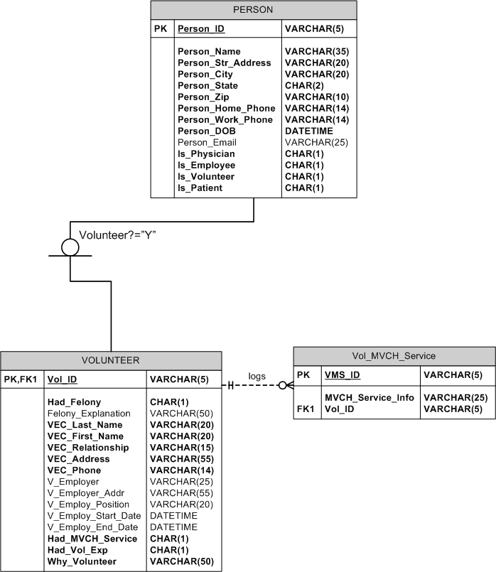
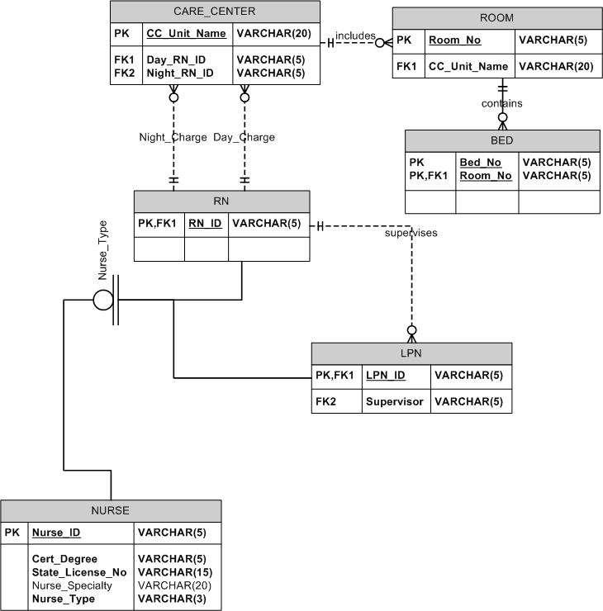

P4.
  - Nurses assigned to each care_center
Assume this report is run 7 times per day, there are 7 Care Centers and 250 Nurses.

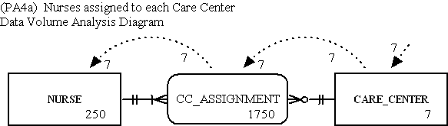

  - 5 most common diagnoses
Again, assume 7 runs per day, 50 different diagnoses and 1,000,000 diagnostic records.

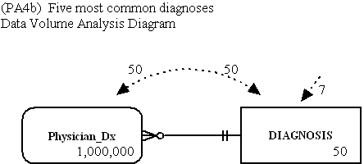

c. Items consumed by each patient; assume run 10 times a day.

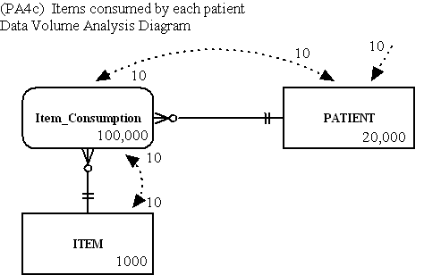

d. Number of items provided by vendors; run 10 times per day; assume 500 vendors.

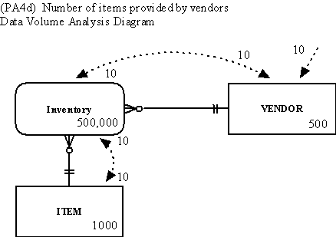

e.
Number of patient admissions per physician; run 10 times per day

